The Haberdashers' Aske's Boys’ School
Elstree, Herts

11+ Entrance Examination 2010

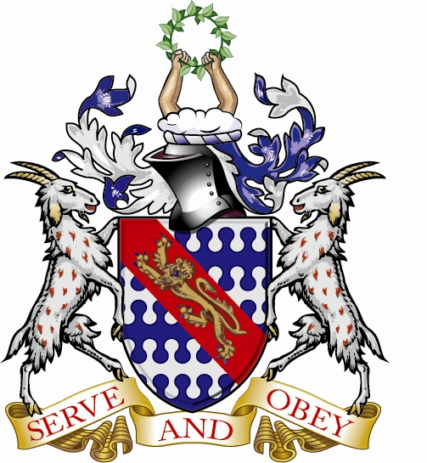

ENGLISH

Time : One Hour

There are two parts to this examination:

Part 1 tests your Reading

Part 2 tests your Writing

Allow yourself 30 minutes for each part.

Please follow these instructions

- Remember to put your name and examination number at the top of each new sheet of paper you use.

- Write in ink, and remember that handwriting and neatness will be taken into account.

- Begin Part 2 (the Writing Exercise) on a new sheet of paper.

- Do not take the question paper away.
READING EXERCISE: 30 MINUTES Scrooge

Read the passage carefully and then attempt all the questions.

In this adapted extract from Chapter 1 of ‘A Christmas Carol’ by Charles Dickens, the reader is introduced to the character of Scrooge…

5  10  15  20  25  30 | Oh! But he was a tight-fisted hand at the grindstone, Scrooge! Hard and sharp as flint, from which no steel had ever struck out generous fire; secret, and self-contained, and solitary as an oyster. The cold within him froze his old features, nipped his pointed nose, shrivelled his cheek, stiffened his gait; made his eyes red, his thin lips blue; and spoke out shrewdly in his grating voice. A frost was on his head, and on his eyebrows, and his wiry chin.  Once upon a time, on Christmas Eve - old Scrooge sat busy in his counting-house. It was cold, bleak, biting weather: foggy too: and he could hear the people in the court outside, go wheezing up and down, beating their hands upon their breasts, and stamping their feet upon the pavement stones to warm them. The city clocks had only just struck three, but it was quite dark already: it had not been light all day: and candles were flaring in the windows of the neighbouring offices. The fog came pouring in at every chink and keyhole, and was so dense outside, that although the street was the narrowest, the houses opposite were phantoms.  The door of Scrooge's counting-house was open that he might keep his eye upon his clerk, who in a dismal little cell beyond, was copying letters. Scrooge had a very small fire, but the clerk's fire was so very much smaller that it looked like one coal. But he couldn't replenish it, for Scrooge kept the coal-box in his own room. The clerk put on his white scarf, and tried to warm himself at the candle; in which effort, not being a man of a strong imagination, he failed.  “A merry Christmas, uncle! God save you!'' cried a cheerful voice. It was the voice of Scrooge's nephew.  “Bah!'' said Scrooge, “Humbug!''  He had so heated himself with rapid walking in the fog and frost, this nephew of Scrooge's, that he was all in a glow; his face was red and handsome; his eyes sparkled, and his breath smoked again.  “Don't be cross, uncle,'' said the nephew.  “What else can I be,'' replied Scrooge, “when I live in such a world of fools! What's Christmas time to you but a time for paying bills without money? If I could work my will, every idiot who goes about with “Merry Christmas'' on his lips, should be boiled with his own pudding, and buried with a stake of holly through his heart!''

ANSWER THE FOLLOWING QUESTIONS ON THE PASSAGE

Questions 1 - 3 may be answered using incomplete sentences or bullet points

1. On what day and at what time does this story take place? 2 marks

2. From the first paragraph, what do we learn about Scrooge’s physical appearance? 6 marks

3. What does Scrooge think should happen to people who celebrate Christmas?
4 marks

Questions 4 – 8 should be answered using complete sentences

4. Why do you think the writer describes Scrooge’s clerk as working in “a dismal little cell”? 4 marks

5. Look at lines 16-22. What does the reader learn about the characters of Scrooge and his clerk in this paragraph, and the conditions in which they work? 6 marks

6. Look at lines 26-28. How is the description of Scrooge’s nephew used as a contrast to the description of Scrooge in paragraph 1? 6 marks

7. Explain how Dickens creates atmosphere in paragraph 2 of this extract. 6 marks

8. Based on the passage as a whole, write a short paragraph describing Scrooge and his office in your own words. 6 marks

Please turn over

WRITING EXERCISE: 30 MINUTES

Begin this exercise on a new sheet of paper. Put your name and exam number at the top.

Choose ONE of the following topics and write about it as interestingly and carefully as you can.

Either

1. In the story you have just read, Scrooge’s clerk is mentioned. Imagine he has been listening to Scrooge and his nephew and decides to take part in the conversation.

What happens next? Be careful to set out what the characters actually say using the correct punctuation.

Or

2. Write a description of your nightmare world.

This could be somewhere real or entirely fictional. You may include characters and speech if you wish. Be careful to describe your world clearly and include as much detail as possible.

