The Haberdashers' Aske's Boys’ School
Elstree, Herts

11+ Entrance Examination 2009

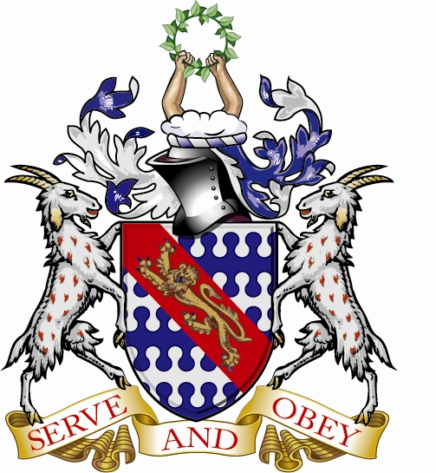

ENGLISH

Time : One Hour

There are two parts to this examination:

Part 1 tests your Reading

Part 2 tests your Writing

Allow yourself 30 minutes for each part.

Please follow these instructions

- Remember to put your name and examination number at the top of each new sheet of paper you use.

- Write in ink, and remember that handwriting and neatness will be taken into account.

- Begin Part 2 (the Writing Exercise) on a new sheet of paper.

- Do not take away the question paper.
READING EXERCISE: 30 MINUTES A Mad Tea Party

Read the passage carefully and then attempt all the questions on it.

In this adapted extract from Chapter 7 of ‘Alice’s Adventures in Wonderland’ by Lewis Carroll, Alice encounters some odd characters...

5  10  15  20  25  30  35 | There was a table set out under a tree in front of the house, and the March Hare and the Hatter were having tea at it. A Dormouse was sitting between them, fast asleep, and the other two were using it as a cushion, resting their elbows on it, and talking over its head. “Very uncomfortable for the Dormouse,” thought Alice. “Only, as it’s asleep, I suppose it doesn’t mind.”  The table was a large one, but the three were all crowded together at one corner of it. “No room! No room!” they cried out when they saw Alice coming. “There’s plenty of room!” said Alice indignantly, and she sat down in a large arm-chair at one end of the table.  “Have some wine,” the March Hare said in an encouraging tone.  Alice looked all round the table, but there was nothing on it but tea.  “I don’t see any wine,” she remarked.  “There isn’t any,” said the March Hare.  “Then it wasn’t very civil of you to offer it,” said Alice angrily.  “It wasn’t very civil of you to sit down without being invited,” said the March Hare.  “I didn’t know it was your table,” said Alice. “It’s laid for a great many more than three.”  “Your hair wants cutting,” said the Hatter. He had been looking at Alice for some time with great curiosity, and this was his first speech.  “You should learn not to make personal remarks,” Alice said with some severity. “It’s very rude!”  The Hatter opened his eyes very wide on hearing this; and here the conversation dropped, and the party sat silent for a minute. The Hatter was the first to break the silence. “What day of the month is it?” he said, turning to Alice: he had taken his watch out of his pocket, and was looking at it uneasily, shaking it every now and then, and holding it to his ear.  Alice considered a little, and then said, “The fourth.”  “Two days wrong!” signed the Hatter. “I told you butter wouldn’t suit the works!” he added, looking angrily at the March Hare.  “It was the best butter,” the March Hare meekly replied.  “Yes, but some crumbs must have got in as well,” the Hatter grumbled. “You shouldn’t have put it in with the bread-knife.”  The March Hare took the watch and looked at it gloomily; then he dipped it into his cup of tea, and looked at it again. But he could think of nothing better to say than his first remark, “It was the best butter, you know.”

ANSWER THE FOLLOWING QUESTIONS ON THE PASSAGE

Questions 1 and 2 may be answered using incomplete sentences or bullet points

1. Where, at the start of the passage, is the tea table set out? 2 marks

2. Write down the names of the 3 characters sitting at the table and say what each is doing.
6 marks
Questions 3 – 10 should be answered using complete sentences

3. Give 2 reasons why it is surprising when they greet Alice with
“No room! No room!” in line 7. 4 marks

4. What does Alice do in lines 6 – 9 to offend the March Hare? 4 marks

5. a) Explain the trick he then decides to play on her.
b) What lesson do you think he wants to teach her? 8 marks
6. In lines 8 - 22, Alice becomes increasingly annoyed. Copy out 3 phrases which prove this. 6 marks

7. In what way is the Hatter’s watch very different from ordinary ones?
4 marks

8. In lines 29 - 35, 3 possible reasons are given for the watch not working properly. What are they? 6 marks

9. Based on the passage as a whole, write a short paragraph describing Alice’s personality. 6 marks

10. Of all the characters in the story, which one would you like to have tea with and why? 4 marks

Please turn over

WRITING EXERCISE: 30 MINUTES

Begin this exercise on a new sheet of paper. Put your name and exam number at the top.

Choose ONE of the following topics and write about it as interestingly and carefully as you can.

Either

1. In the story you have just been studying, the Dormouse says nothing. Imagine he has been listening for most of the time and now decides to wake up properly and take part in the tea party.

What happens next? Be careful to set out what the characters actually say using the correct punctuation.

Or

2. Write about the best lesson you have ever been taught.

Perhaps it was in school or perhaps it was something you learned as a result of an experience with friends or family. What happened and what sort of things did you learn?

